Web Application Security Assessment Report

Project Title
Future Interns – Cyber Security Task 1

Student Name:

Internship ID:

Date:

1. Introduction
This project focuses on performing a basic web application security assessment on a vulnerable web application. The goal is to identify common vulnerabilities, analyze their impact, and recommend appropriate remediation measures using standard security tools and OWASP Top 10 guidelines.

2. Objective
- To understand basic web application vulnerabilities
- To perform automated and manual security testing
- To identify security flaws
- To map vulnerabilities to OWASP Top 10
- To suggest remediation techniques

3. Tools Used
Tool Name | Purpose
OWASP ZAP | Automated scanning
Burp Suite | Manual testing
Kali Linux / Windows | Testing environment
Browser | Interaction with web app

4. Target Application Details
Parameter | Value
Application Name | (DVWA / Juice Shop / bWAPP)
Hosting | Localhost / VM
URL | http://
Login Required | Yes / No

5. Methodology

5.1 Automated Scanning
OWASP ZAP was used to crawl and actively scan the application for common vulnerabilities.

5.2 Manual Testing
Manual testing was performed using Burp Suite to intercept and manipulate HTTP requests. Input fields were tested for SQL Injection, XSS, and CSRF vulnerabilities.

6. Vulnerability Findings

6.1 SQL Injection
Description: SQL Injection allows attackers to manipulate database queries.
Affected URL:
Payload Used:
Impact: High / Medium / Low

Evidence (Screenshot):
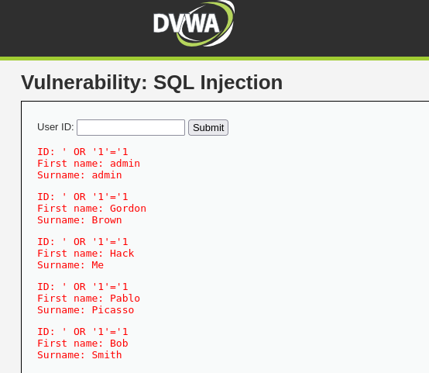
OWASP Category: A03 – Injection
Remediation: Use prepared statements, parameterized queries, and input validation.

6.2 Cross-Site Scripting (XSS)
Description: XSS allows attackers to inject malicious scripts.
Affected URL:
Payload Used:
Impact: High / Medium / Low
Evidence (Screenshot):
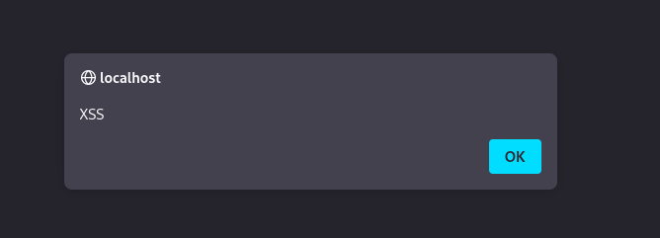
OWASP Category: A07 – XSS
Remediation: Sanitize user input, encode outputs, use CSP.

6.3 Cross-Site Request Forgery (CSRF)
Description: CSRF tricks users into performing unwanted actions.
Affected Feature:
Impact: Medium / Low
Evidence (Screenshot):
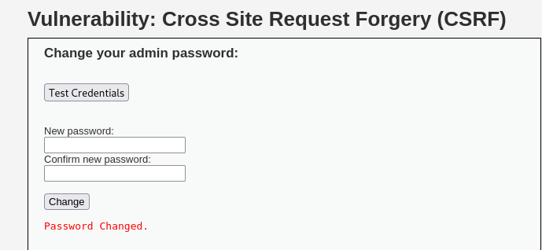
OWASP Category: A05 – Security Misconfiguration
Remediation: Use CSRF tokens, same-site cookies.
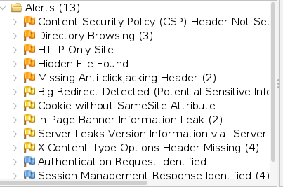
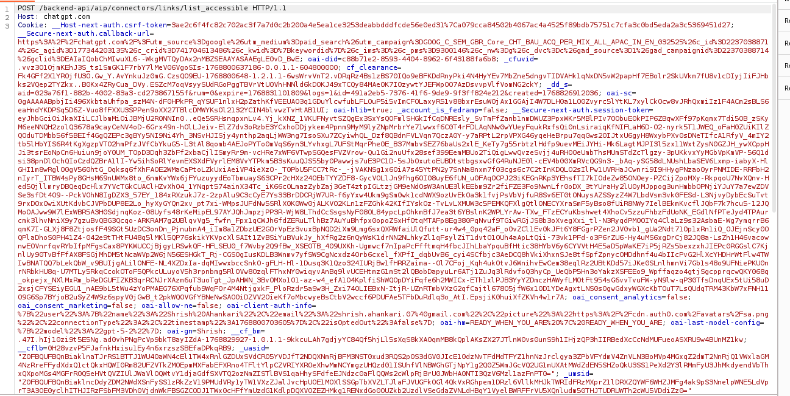

7. OWASP Top 10 Mapping
Vulnerability | OWASP Category
SQL Injection | A03 – Injection
XSS | A07 – XSS
CSRF | A05 – Security Misconfiguration

8. Risk Analysis
Vulnerability | Likelihood | Impact | Risk Level
SQL Injection | High | High | Critical
XSS | Medium | Medium | Moderate
CSRF | Low | Medium | Low

9. Conclusion
This assessment demonstrated how common web vulnerabilities can be identified using both automated and manual techniques. Proper security measures must be implemented to protect applications from exploitation.

10. References
- OWASP Top 10
- OWASP ZAP Documentation
- Burp Suite Documentation

11. Appendix
- Tool Scan Logs
- Screenshots
- Payload List

